PERSONAL PROFILE
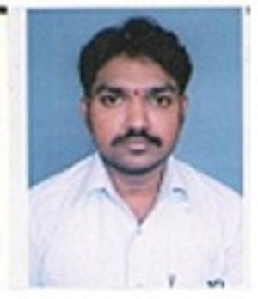

Attach photo
D sivashankar, M.Tech
Lecturer in computer science ,
S.K.P Government College,
Guntakal, Anantapur District, Andhra Pradesh,
Mobile: 8008686400
Email: sivashankar.dasari@gmail.com
_________________________________________________________________________________

- National / International seminars or Work Shops/Trainings attended :

S.No | National/ International | Institution/place | Date | Title of the paper Presented
1 | National | Gates institute of technology | 20th Feb,2009 | Workshop on Systems Integration Microsoft  Microsoft & IEG/JKC
2 | National | JNTUA | 22nd & 23rd DEC, 2010. | software Systems: Practice, Research and Engineering (ASPIRE’10)
3 | National | Cognizant, Hyderabad | 20th Dec, 2011 | RIPPLE
4 | Inter National | BIT INSTITUTE OF TECHNOLOGY - HINDUPUR | 2 July 2020 to 26 July 2020 | FIVE DAY INTERNATIONAL WORKSHOP ON EMERGING TRENDS
5 | National | SRM Institute of science and technology | 05/07/2020 | Cloud ERP Automation
6 | National | Pope’s College (Autonomous) | 3rd July 2020 | CLOUD COMPUTING
7 | National | JAIN DEMEED UNIVERSITY | June 29, 2020 | Development Program on Performance Engineering
8 | National | SRIA.B.RGOVERNMENTDEGREECOLLEGE | 26/06/2020 | ANALYTICAL SKILLS

